200687M Vishwamith P.G.H Assignment 2

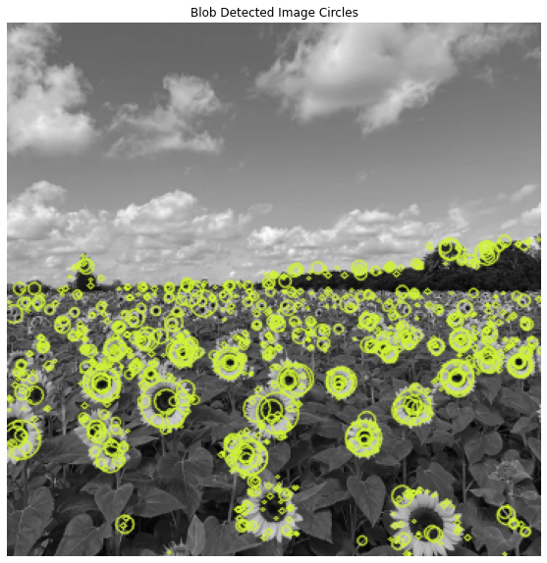Q1)

Largest Circle Sigma value range: (0.1,2.8)

Center : (106, 257)

Radius : 16

Sigma : 2.8

Code for detecting blobs/circles

Q2)

Q2)

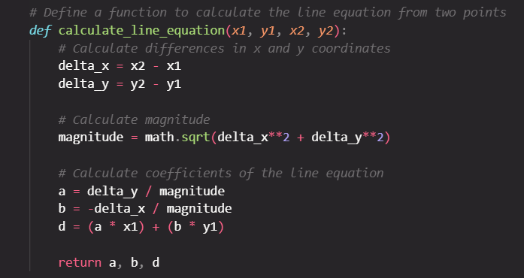

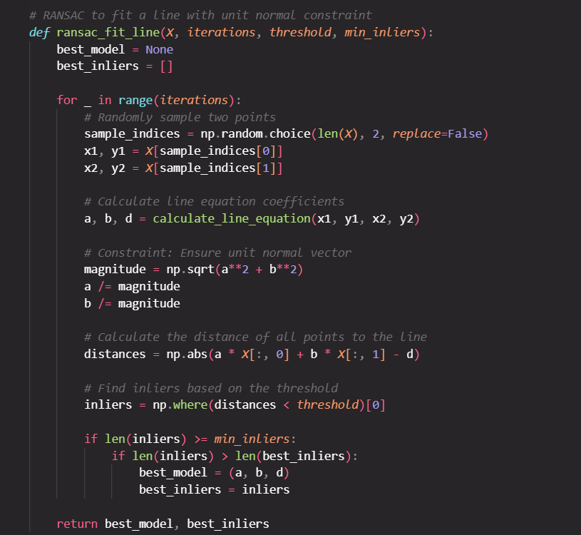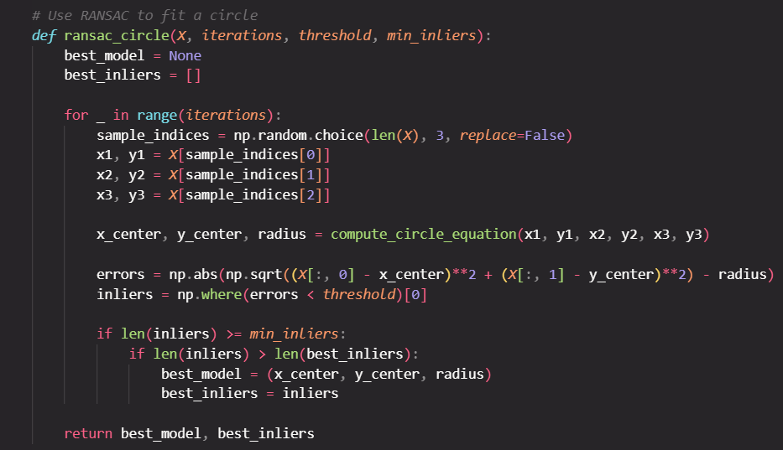

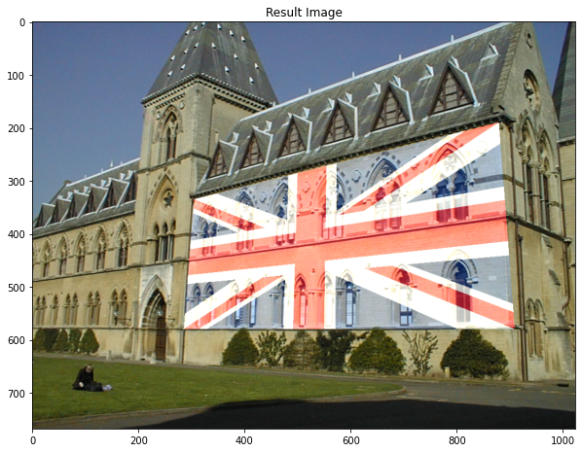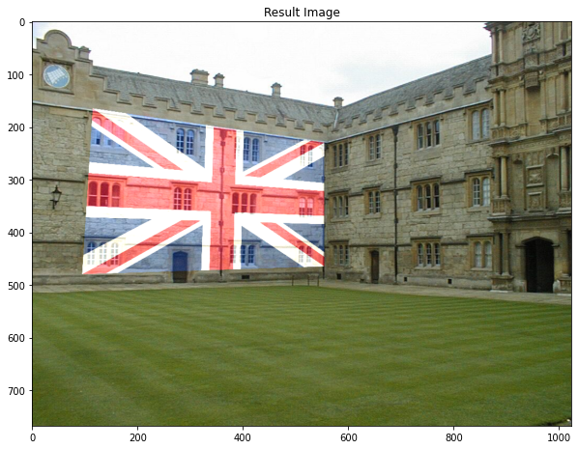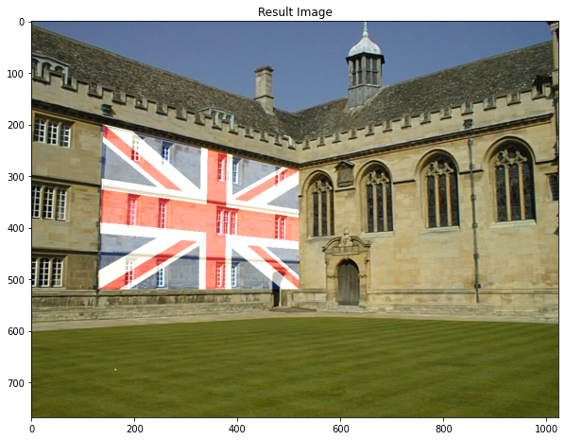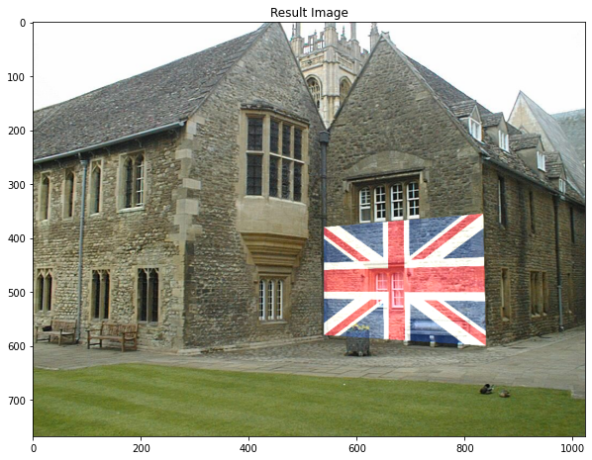Q3